Supporting Information for
Extended Profiles Including Surface-Layer Wind Speed Improve Farm-Scale Wind Power Forecasting
Xin Xia¹, Rong Zhu^{1,2}, Rui Chang², Martin Dörenkämper³, Peidu Li⁴, and Yong Luo^{1,*}
¹Ministry of Education Key Laboratory for Earth System Modeling, Department of Earth System Science, Tsinghua University, Beijing 100084, China
²National Climate Center of China Meteorological Administration (CMA), Beijing 100081, China
³Fraunhofer Institute for Wind Energy Systems, Bremerhaven, Germany
⁴Plateau Atmosphere and Environment Key Laboratory of Sichuan Province, School of Atmospheric Sciences, Chengdu University of Information Technology, Chengdu 610225, China
*Corresponding author: Yong Luo (Yongluo@tsinghua.edu.cn)

Contents of this file

Text S1 to S4
Figure S1 to S2
Introduction
The supporting information for this article contains:
- CEEMDAN decomposition and scale-resolved correlation analysis methodology (Text S1)
- Empirical Orthogonal Function (EOF) analysis of vertical wind structure (Text S2)
- Machine learning model implementation, data splitting, and experimental design for power reconstruction (Text S3)
- Day-ahead power forecasting experimental design, strategy implementation, and evaluation (Text S4)
- Wind farm layout and meteorological mast location (Figure S1)
- Spearman rank correlation matrices among multi-height wind speeds and farm power under different flow regimes (Figure S2)

Text S1. CEEMDAN Decomposition and Scale-Resolved Correlation Analysis
To investigate the scale-dependent coupling between vertical wind measurements and farm-scale power output, continuous wind speed time series at 10 m, 30 m, 50 m, and 70 m, together with total farm power, were decomposed using Complete Ensemble Empirical Mode Decomposition with Adaptive Noise (CEEMDAN). CEEMDAN (Torres et al., 2011) provides an adaptive, data-driven representation of nonlinear and non-stationary signals by decomposing a time series $x\left(t\right)$ into intrinsic mode functions (IMFs) and a residual term,
$$x\left(t\right)=\sum_{i=1}^{K}{IMF_{i}\left(t\right)}+r_{K}\left(t\right)$$
where each IMF represents oscillatory variability at a characteristic time scale and $r_{K}\left(t\right)$ denotes the long-term trend. Decomposition was performed using 100 ensemble trials with a noise amplitude of 0.005, and a fixed random seed was applied to ensure reproducibility. Prior to decomposition, only timestamps containing valid measurements at all heights and for power were retained to guarantee consistent sample alignment across variables. Flow regimes were classified using the strict multi-height directional criteria described in Section 2.1, and corresponding masks were applied after decomposition to isolate free-stream and wake-influenced subsets.
To associate each IMF with a representative time scale, an average period was estimated from the number of zero crossings $n_{zc}$ within each IMF. For a time series containing $N$ samples and sampling interval $Δt$, the characteristic period of the $i-th$ IMF was computed as
$$T_{i}=\frac{2N}{n_{zc}}Δt$$
This formulation provides an empirical estimate of oscillation period without assuming stationarity. Scale-dependent relationships were then quantified using Spearman rank correlation coefficients between corresponding IMFs from two variables,
$$ρ_{s}^{\left(i\right)}=ρ_{s}\left(IMF_{i}^{\left(X\right)},IMF_{i}^{\left(Y\right)}\right)$$
where $ρ_{s}^{\left(i\right)}$ denotes the correlation associated with variability at time scale $T_{i}$. Correlations were computed for the full dataset as well as separately for free-stream and wake-influenced subsets. This procedure yields a continuous mapping between variability time scale and vertical coherence or wind–power coupling strength, forming the basis for the scale-resolved analyses presented in Figure 2.

Text S2. Empirical Orthogonal Function (EOF) Analysis of Vertical Wind Structure
EOF (Wilks, 2011) analysis was applied to quantify the dominant vertical structure of wind variability across measurement heights. Wind speed observations were organized into a two-dimensional matrix $U∈R^{N×4}$, where $N$ denotes the number of time samples and the four columns correspond to wind speeds at 10 m, 30 m, 50 m, and 70 m. The temporal mean at each height was removed prior to analysis to isolate variability from the climatological shear profile. No additional normalization was applied, so the decomposition reflects variance structure in physical units.
The covariance matrix across heights was computed as
$$C=\frac{1}{N-1}U^{'T}U^{'}$$
where $U^{'}$ represents the anomaly matrix. Eigenvalue decomposition of $C$ yields orthogonal spatial modes $ϕ_{k}$ and corresponding eigenvalues $λ_{k}$. The anomaly field can be expressed as
$$U^{'}\left(t\right)=\sum_{k=1}^{4}{a_{k}\left(t\right)ϕ_{k}}$$
where $a_{k}\left(t\right)$ denotes the principal component time series of mode $k$. The fraction of variance explained by each mode is given by
$$\frac{λ_{k}}{\sum_{j=1}^{4}{λ_{j}}}$$
EOF analysis was conducted separately for free-stream and wake-influenced conditions using the regime masks defined in Section 2.1. The first mode explains more than 93% of total vertical variance under both regimes, and its spatial structure remains nearly unchanged. To evaluate scaling capability, least-squares linear regression was performed between wind speed at a given height $u_{h}\left(t\right)$ and the first principal component $a_{1}\left(t\right)$:
$$u_{h}\left(t\right)=α_{h}a_{1}\left(t\right)+β_{h}$$
where $α_{h}$ represents the scaling coefficient. Regression slopes were compared across regimes to assess whether wake effects alter the relationship between individual-height wind speed and column-integrated variability.

Text S3. Machine Learning Model Implementation and Experimental Design
Starting from the quality-controlled observational dataset described in Section 3.1, additional task-specific filtering was applied for the reconstruction experiment. Farm-scale power reconstruction was implemented using the LightGBM gradient boosting regression model (Ke et al., 2017). The initial matched dataset contained 52,317 samples. After removing negative power values, missing observations, and wind speeds outside the operational range of 3–25 m s⁻¹ at 70 m, 45,189 valid samples remained for analysis. The dataset was randomly divided into training (80%) and testing (20%) subsets, yielding 36,151 training samples and 9,038 test samples for each input configuration. This identical data split was used for all model comparisons to ensure fair evaluation. Random splitting was adopted for the reconstruction experiment because the task uses concurrent observational inputs and outputs without temporal lead time, making temporal ordering less critical than in forecasting applications.
Three input configurations were evaluated: hub-height wind speed only (HH, 70 m), Standard REWS using wind speeds at 30 m, 50 m, and 70 m (SR), and Extended REWS including surface-layer wind speed at 10 m in addition to rotor-layer measurements (ER). All models included 10-m air temperature as an additional predictor to account for density effects. Figure 3A reports reconstruction performance on the full test dataset using models trained on all samples without regime separation. Figure 3B evaluates regime-dependent performance by applying these same globally trained models to test subsets classified as free-stream and wake-influenced conditions, without retraining. This design isolates the impact of inflow regime on predictive skill while keeping model structure fixed.
For the regime-specific SHAP analysis shown in Figure 3C, regime classification was performed prior to model training. Separate LightGBM models were trained exclusively using samples belonging to each regime. After quality control and regime filtering, the dataset comprised 1,951 free-stream samples and 8,693 wake-influenced samples. These subsets were independently divided into training and testing sets using the same 80/20 split ratio. SHapley Additive exPlanations (SHAP; Lundberg & Lee, 2017) were then computed on the corresponding test sets to quantify feature contributions under each regime. This experimental design allows direct assessment of whether model behavior aligns with the physical mechanisms identified in Sections 4.1 and 4.2.
Model Parameter Settings
All LightGBM models were trained using identical hyperparameter settings across configurations to isolate the effect of input representation. The gradient boosting decision tree algorithm was used with the following settings: number of boosting iterations (n_estimators) = 100, learning rate = 0.1, maximum number of leaves per tree (num_leaves) = 31, feature subsampling fraction (feature_fraction) = 0.8, bagging fraction = 0.8, L1 regularization (reg_alpha) = 0.1, L2 regularization (reg_lambda) = 0.1, and minimum number of samples per leaf node (min_child_samples) = 20. A fixed random seed (random_state = 42) was applied to ensure reproducibility. These parameters were kept constant across HH, SR, and ER models, and no regime-specific hyperparameter tuning was applied. Training and test sets were split using random sampling (test_size = 0.2, random_state = 42). Model performance was evaluated using coefficient of determination (R²) and root mean square error (RMSE) computed on the withheld test data.

Text S4. Day-Ahead Power Forecasting: Experimental Design and Strategy Implementation
Building on the same quality-controlled dataset (Section 3.1), task-specific filtering was applied for the day-ahead forecasting experiment. Day-ahead forecasting experiments were conducted using dynamically downscaled meteorological predictions from the WRF model. The WRF configuration, including physics parameterizations and nesting strategies, is documented in Xia et al. (2026). Two NWP systems were evaluated independently, driven by ECMWF and GFS global forecasts. For each system, the matched dataset was first filtered to remove negative power values and samples with missing meteorological inputs. Wind speeds outside the operational range of 3–25 m s⁻¹ at 70 m were excluded. After quality control, the dataset was divided into training and testing subsets using a chronological 80/20 split without random shuffling to preserve temporal structure. Unlike the reconstruction experiment (Text S3), chronological splitting was used here to simulate realistic operational conditions, in which the model must predict future power output from NWP inputs without access to future observations. Wind-direction classification for both training and testing data was performed using the 70-m wind direction predicted by the corresponding NWP system. Samples were assigned to free-stream (225°–315°), wake-influenced (45°–135°), or other sectors based on the predicted wind direction.
All forecasting strategies adopted a two-stage learning framework. In the first stage, each NWP meteorological variable was individually bias-corrected using a LightGBM regression model trained to map NWP inputs to the corresponding observed variable at the same height, following common post-processing practice (Cassola & Burlando, 2012). In the second stage, the set of corrected meteorological variables was used to train a separate LightGBM model to predict farm-scale power. This design ensures that the conversion from meteorological variables to power is learned using observation-consistent inputs rather than raw NWP outputs.
Four forecasting strategies were compared. The HH strategy used NWP wind speed at 70 m and 10-m temperature. The SR strategy used wind speeds at 30 m, 50 m, and 70 m together with 10-m temperature. The ER strategy included wind speeds at 10 m, 30 m, 50 m, and 70 m along with 10-m temperature. The wind-direction-aware (WDA) strategy differed in that three separate two-stage models were trained independently for free-stream, wake-influenced, and other wind-direction sectors. During prediction, each test sample was first classified using NWP-predicted 70-m wind direction, and the corresponding sector-specific model was dynamically applied. This approach allows the effective meteorological inputs to vary according to inflow regime while maintaining the same training framework.
Forecast performance was evaluated on the 20% test subset using R², RMSE, mean absolute error, and Pearson correlation coefficient. Statistical significance of differences in forecast accuracy between strategies was assessed using the Diebold–Mariano test (Diebold & Mariano, 1995) applied to squared forecast errors. All experiments were performed using a fixed random seed to ensure reproducibility.
Model Parameter Settings
Identical LightGBM hyperparameters were used for both bias-correction and power-prediction stages and across all forecasting strategies: num_leaves = 31, learning_rate = 0.05, feature_fraction = 0.9, bagging_fraction = 0.8, bagging_freq = 5, and n_estimators = 100 (random_state = 42). These settings differ slightly from those used in the reconstruction experiment (Text S3), where a higher learning rate (0.1) and additional regularization (reg_alpha = 0.1, reg_lambda = 0.1) were applied. The forecasting experiment adopted a lower learning rate to improve generalization over longer prediction horizons where NWP input uncertainty is higher.

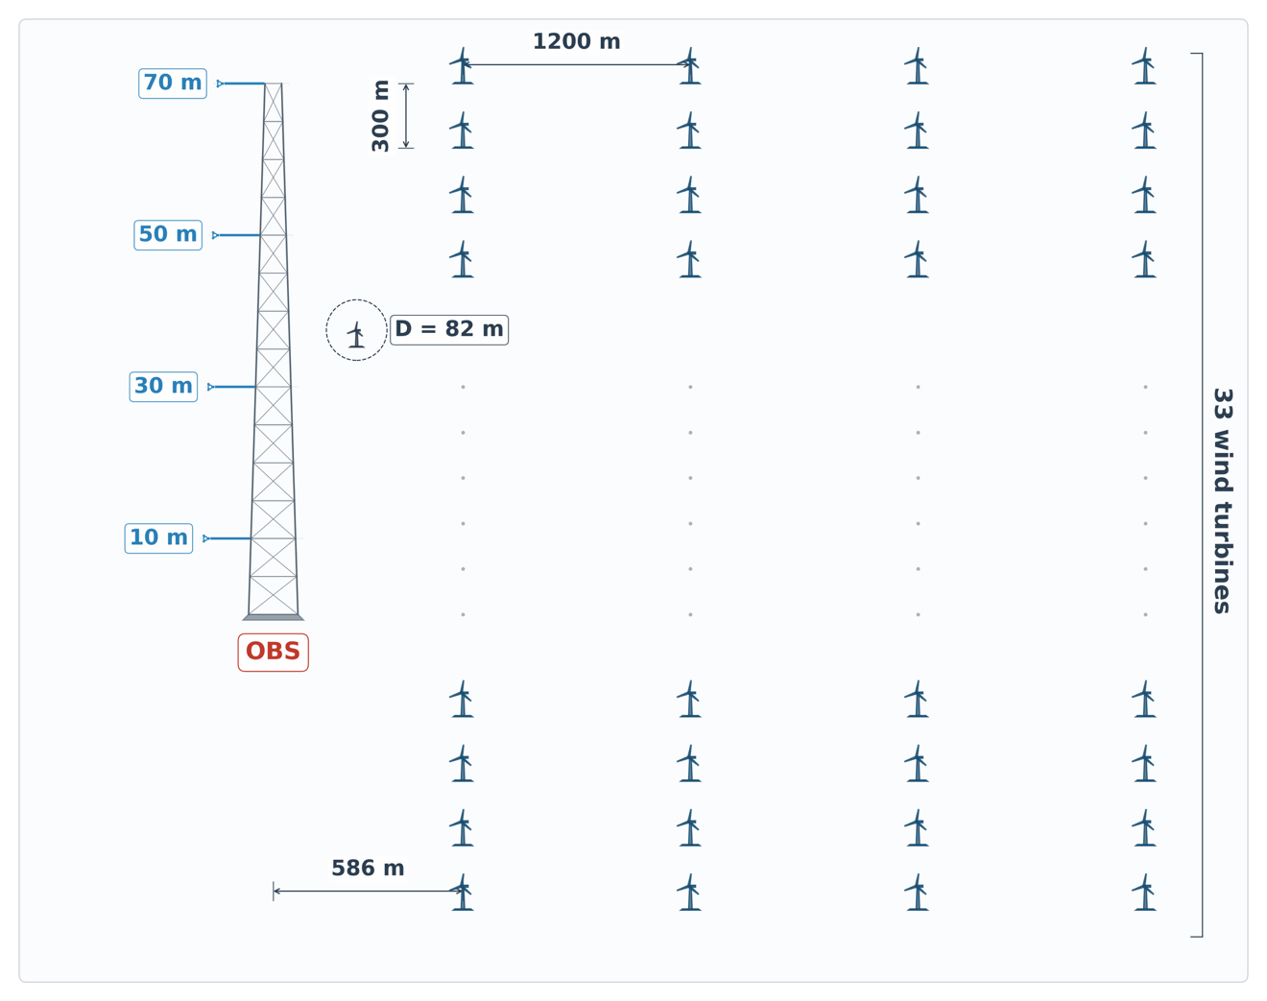

Figure S1. Schematic of the wind farm layout and meteorological mast configuration. The 70-m observation mast (OBS) is located 586 m west of the first turbine column. Wind speed and direction are measured at four heights (10 m, 30 m, 50 m, and 70 m). The farm comprises 134 turbines (33 rows × 4 columns, plus 2 additional turbines) with approximately 300-m row spacing and 1200-m column spacing. Each turbine has a rotor diameter (D) of 82 m and a hub height of 61.5 m. Westerly winds (from left) represent free-stream conditions at the mast, whereas easterly winds (from right) traverse the turbine array before reaching the mast, corresponding to wake-influenced conditions.

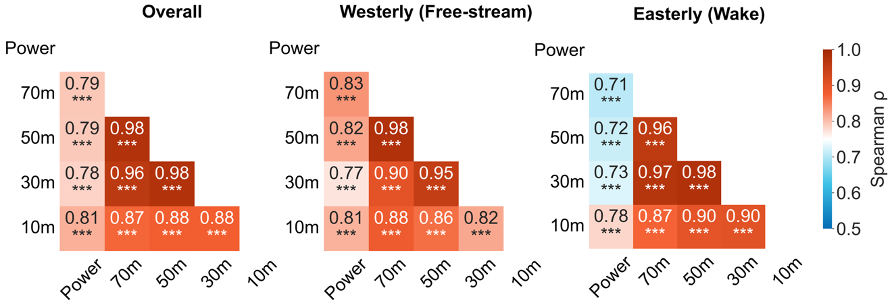

Figure S2. Spearman rank correlation matrices among wind speeds at four measurement heights and total farm power. Results are shown for overall (left), free-stream (center), and wake-influenced (right) conditions. Asterisks indicate statistical significance (*** p < 0.001).

References
Cassola, F., & Burlando, M. (2012). Wind speed and wind energy forecast through Kalman filtering of Numerical Weather Prediction model output. Applied Energy, 99, 154–166. https://doi.org/10.1016/j.apenergy.2012.03.054
Diebold, F. X., & Mariano, R. S. (1995). Comparing Predictive Accuracy. Journal of Business & Economic Statistics, 13(3), 253–263. https://doi.org/10.1080/07350015.1995.10524599
Ke, G., Meng, Q., Finley, T., Wang, T., Chen, W., Ma, W., et al. (2017). Lightgbm: a highly efficient gradient boosting decision tree. Advances in Neural Information Processing Systems, 30.
Lundberg, S. M., & Lee, S.-I. (2017). A unified approach to interpreting model predictions. Advances in Neural Information Processing Systems, 30.
Torres, M. E., Colominas, M. A., Schlotthauer, G., & Flandrin, P. (2011). A complete ensemble empirical mode decomposition with adaptive noise. In 2011 IEEE International Conference on Acoustics, Speech and Signal Processing (ICASSP) (pp. 4144–4147). Prague, Czech Republic: IEEE. https://doi.org/10.1109/ICASSP.2011.5947265
Wilks, D. S. (2011). Statistical methods in the atmospheric sciences (Vol. 100). Academic press.
Xia, X., Luo, Y., Li, P., & Chang, R. (2026). Comparative evaluation of ECMWF and GFS for operational day-ahead wind speed forecasting. Renewable Energy, 261, 125263. https://doi.org/10.1016/j.renene.2026.125263

